**JavaScript/Automatic semicolon insertion (ASI)**

Semicolon is an English punctuation denotes to end of a JS statement. Unlike other programming languages, Semicolon in JS is **optional** which means it’s not necessary to use a semicolon at the end of a statement. As JavaScript **Engine** will "intelligently" **add** them when it running the code.

In JavaScript, a semicolon is automatically inserted when:

1. two statements are separated by a line terminator
2. Before the closing ('}').
3. a line terminator follows a [break](https://en.wikibooks.org/wiki/JavaScript/Reserved_words/break), [continue](https://en.wikibooks.org/wiki/JavaScript/Reserved_words/continue), [return](https://en.wikibooks.org/wiki/JavaScript/Reserved_words/return), or [throw](https://en.wikibooks.org/wiki/JavaScript/Reserved_words/throw).

**Example 1:**

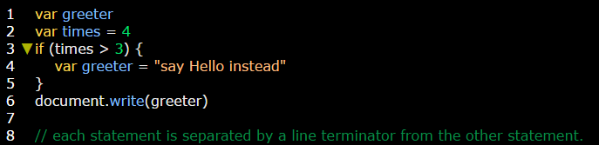

**Example 2:**

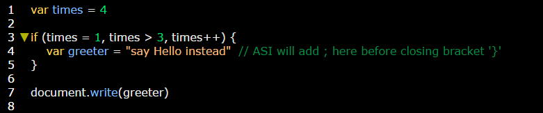

**Example 3:**

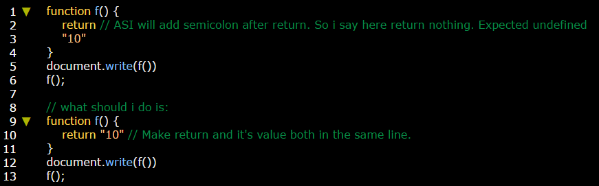

**Note:** what happens with return happen in [break](https://en.wikibooks.org/wiki/JavaScript/Reserved_words/break), [continue](https://en.wikibooks.org/wiki/JavaScript/Reserved_words/continue), and [throw](https://en.wikibooks.org/wiki/JavaScript/Reserved_words/throw).

**Pons of ASI:**

* ASI would make your code easier to write (no need to type all of those semicolons).

**Pros of ASI:**

* Lack of semicolons makes your program harder to debug.
* ASI doesn’t put semicolon in **three** cases:

1. If the line ends with a plus operator like "+", then JS engine will know that is an “incomplete expression”, so it won’t add semicolon.
2. JS engine does not assume a semicolon before square brackets [...].
3. If two statements can get together in one line.

**Example 1:**

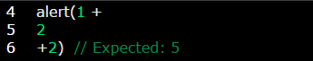

**Example 2:**

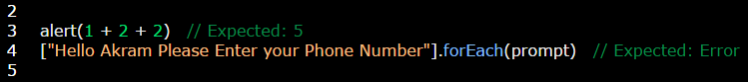

**Example 3:**

